*A project report on*

**FOOD COURT BASED WEB APPLICATION**

*Submitted in partial fulfillment for the award of the degree of*

**Integrated MTech (MTSE & MTCSE)**

*by:*

**S. JAYADRITHA -21MIC7114**

**T. ANJALI SRI-21MIS7068**

**P. REVANTH -21MIS7038**

**G. BHUVAN-21MIS7023**

**Y. PAVAN – 21MIC7043**

**DEPARTMENT OF SCOPE**

**VIT-AP UNIVERSITY**

**AMARAVATI**

**ANDHRA PRADESH, INDIA**

April - 2024

**DECLARATION**

I hereby declare that the project entitled “FOOD COURT BASED WEB APPLICATION” submitted by me, for the award of the degree of Specify the name of the degree VIT is a record of bonafide work carried out by me under the supervision of Guide Name

I further declare that the work reported in this project has not been submitted and will not be submitted, either in part or in full, for the award of any other degree or diploma in this institute or any other institute or university.

**Place: Amaravati**

**Date: 27-04-2024**

**Signature of all team members**

S. JAYADRITHA

T. ANJALI SRI

P. REVANTH

G. BHUVAN

Y. PAVAN

**CERTIFICATE**

This is to certify that the “SOFTWARE PROJECT MANAGEMENT SYSTEM” project title **“FOOD COURT BASED WEB APPLICATION”** that is submitted by S.JAYADRITHA (21MIC7114) is in partial fulfilment of the requirement for the award of Bachelor of Technology, is a record of bonafide work done under my guidance. The contents of this project Work, in full or in parts, have neither been taken from any other source nor have been submitted to any other institute or University for award of any degree or diploma and the same is certified.

**Prof. Anurag De – SCOPE**

***Guide***

**ABSTRACT**

The Food Court Management System is a web-based platform designed to streamline and enhance the overall process of food ordering, delivery, and management. In an era characterized by rapid technological advancements and changing consumer preferences, this system addresses the growing demand for efficient and user-friendly solutions in the food industry. The system encompasses a user-friendly interface for both customers and restaurant owners, offering a seamless and convenient experience. Customers can easily browse through a diverse range of menus, place orders, and track their delivery in real-time. On the other hand, restaurant owners can efficiently manage their menu items, process orders, and monitor business performance through a centralized dashboard.

The Food Court Management System aims to revolutionize the way food businesses operate by leveraging technology to enhance customer satisfaction, streamline operations, and foster growth. By providing a comprehensive solution for online food management, this system contributes to the digital transformation of the food industry, catering to the evolving needs of both customers and restaurant owners.

**ACKNOWLEDGEMENT**

It is my pleasure to express with deep sense of gratitude to prof. Anurag de, Amaravati, Scope, VIT-AP, for his/her constant guidance, continual encouragement, understanding; more than all, he taught me patience in my endeavor. My association with him / her is not confined to academics only, but it is a great opportunity on my part of work with an intellectual and expert in the field of Inavolu.

I would like to express my gratitude to DR. KOTTA REDDY (VICE CHANCELLOR-VITAP), DR. JAGADISH CHANDRA MUDIGANTI -REGISTER for providing with an environment to work in and for his inspiration during the tenure of the course.

In jubilant mood I express ingeniously my whole-hearted thanks to <Program char- name>. <Program Chair designation>, all teaching staff and members working as limbs of our university for their not-self-centered enthusiasm coupled with timely encouragements showered on me with zeal, which prompted the acquirement of the requisite knowledge to finalize my course study successfully. I would like to thank my parents for their support.

It is indeed a pleasure to thank my friends who persuaded and encouraged me to take up and complete this task. At last but not least, I express my gratitude and appreciation to all those who have helped me directly or indirectly toward the successful completion of this project.

**Place: Amaravati**

**Date: 27-04-24**

**Name of all team members**

S. JAYADRITHA

T. ANJALI SRI

P. REVANTH

G. BHUVAN

Y. PAVAN

**CONTENTS**

**ABSTRACT……………………………………………………………………………….i**

**LIST OF TABLES………………………………………………………………………iv**

**LIST OF FIGURES…………...………………………...…………………………v**

**LIST OFABBREVIATIONS…………………………………………………………vi**

**CHAPTER 1. INTRODUCTION……………………………………………………………. 01** 1.2 Rationale…….………………………………………………………… 01

1.3 Objectives….…………...………………………………………………02

1.4 Needs of Online Food Order .………………………...………………..02

1.5 Functionalities…….……………………………………………………02

1.1 Introduction..…………………………………………………………... 01

1.6 Features.......……..……………………………………………………..03

**2. LITERATURE REVIEW…….………………………………………………..04** 2.1 Background of the studies……………………………………………..04

**3. METHODOLOGY…………………...…..…..………………………………...06**

3.1 Complete Visualization of Online Food Ordering System….................06

3.2 Tools and Technique.....…………………………………….…….…....07

3.2.1 Php………………………………………………………...08

3.2.2 XAMPP…………………………………………………...08

3.2.3 MySQL yog…………………………………………….....09

3.2.4 HTML……………………………………………………..09

3.2.5 Bootstrap……………………………………………….… 09

3.2.6 Java Script……………………………………………..…..10

3.2.7 Sublime Text……………………………………………....10

3.2.8 GitHub..……………………………………………….…...10

3.2.9 CSS….………………………………………………….….10

3.3 Methodology Development Model……...…...…...….…………..…....11

3.4 System Model Design……………………………...………………….12

3.5 Admin workflow Process………….……………………………..….…13

**ANALYSIS , RESULT & DISCUSSION………………………………….…...23**

4.1 System Implementation Plan…………………………………………..23

4.1.1 Project Planning……….……………………………………23

4.2 Facing Problem During Development the Project……………………..24

4.3 Final Output……..……………………………………………………..25

4.4 Result & Discussion…….…………………………………………...…26

4.5 Application…………………………………………………….……….26

4.6 Advantages………………………………………………………….….27

4.7 Limitations of the System……………..…….………………………....27

**5. CONCLUSION & FUTURE WORK……………………………………….....28**

5.1 Conclusion……………………………………………………..……....28

5.2 Future Work…………………………………..………………………..29

**REFERENCES ……………………………………………………………………………...…30**

### LIST OF FIGURES

**Figure No. Title Page**

Figure 3.3.1 Use Case Diagram…………….......….….…………………….……...17 Figure 3.4.1 E-R Diagram …………..………………….…………….……..18

Figure 3.5.1 Class Diagram ….……………………………………...…..................18

Figure 3.6.1 Sequential Diagram.…………………………………….….................19

Figure 3.7.1.1 Activity Diagram …………………………………….……………..20

**LIST OF TABLES**

2.1 MULTIPATH ROUTING PROTOCOLS IN AMNETS 22

* 1. SIMULATION PARAMETERS 48

**LIST OF ABBREVIATIONS**

**PHP** Hypertext Preprocessor(Open source scripting language).

**MySQL** "My", the name of co-founder Michael Widenius's

daughter My, and “SQL’’ the abbreviation for Structured Query

**CGI** Common Gateway Interface.

**CLI** Command-Line Interface.

**CRM** Customer Relationship management.

**XAMPP** for Cross-Platform (X), Apache (A), MariaDB (M), PHP (P)

and Perl (P).(a free and open source cross-platform web server

**HTTP** Hypertext Transfer Protocol (set of rules for transferring files).

**HTML** Hypertext Markup Language.

**CSS Cascading Style Sheets.**

**API** Aplication Programming Interface.

**SCM** Source Code Management.

**E-R Diagram** Entity Relationship Diagram.

**Chapter 1**

**Introduction**

Currently, the way schools/college canteens work is that you pay for the food and you wait for the food in line but the problem is that all the students in a facility have the same time slot for the break hence a group of people end up rushing towards the canteen at the same time this creates a lot of inconvenience for the canteen staff as well as the students and since the time is limited some students end up not eating food or wasting their food. This is where the Canteen Management system enters it helps in streamlining the whole process wherein students can order their food and via their phones beforehand from the website in which the user has to enter the college email id and then they are ready to order via e-menu and do the payments as well and this helps the college to keep a track on the canteens transactions.[in case of any frauds] and as soon as a user orders anything the website will alert about it the kitchen staff and they can start preparing it. Ultimately Canteen Management System will help streamline this whole to the cumber some process and change the age-old ways of doing things The online canteen food ordering system contains e-menu cards that contain the details of the food. It will provide the list of their various item menu list. The customer can select the desired item and can pay the amount. Immediately after booking, the canteen people from the various will get the information of the order and they will prepare the order. The food will be ready in advance and the customers need not wait near the delivery place. The digitalization of the canteen system will help provide better service to the users and the time consumption will be reduced. The up dation and deletion of any item can be done. The online system will be helpful for the food makers to prepare the food as early as possible. As a result, there will be quick service to the customers. No queues can be formed for waiting for the food. The up dation of the data to the database will be monitored by the admin. The user’s data like recognizing the regular users to the canteen will be done and sent to the database. The security of data is done by the encrypted format and server databases of the institution.

* 1. **OBJECTIVE**

The main objective of the project on canteen Management system is to manage the details of Canteen type. The project is built at the administration end and thus only the administrator has authority to access it. The purpose of the performing and executing project is to build about the Canteen Categories and its type. Functionalities provided by Canteen Management System are as follows:

* It tracks all the information of the possible students, Bill Payaments, Meal Type, etc.
* Provides the sorting of the end searching facilities based on various factors. Such as company Canteen, Students Meal, and Meal Type.
* Manage the information of the by Editing, Adding, and updating Records is improved which results in proper resource management of company Canteen data.
* Manage the information of the on Meal Type ll.

**1.2 Organization of the Report:**

Chapter 1 contains introduction, objectives.

Chapter 2 contains the proposed system, methodology and software details.

Chapter 3 gives the cost involved in the implementation of the project.

Chapter 4 discusses the results obtained after the project was implemented.

Chapter 5 concludes the project.

Chapter 6 consists of codes.

Chapter 7 gives references.

**1.3 PROPOSED SYSTEM:**

This device is usually high quality for fending off spending time ready with inside the queue via way of means of posting orders without delay to the kitchen immediately and additionally via way of means of performing scheduling orders beforehand of time. It saves time and additionally the method coping with is easy. The proposed Canteen Management System is an adept answer for chaos at university canteens. Highlights of cloud as an instance auto-scaling, load adjusting and pay as you go enhance the running of the device and to a point resolve the motivation in the back of the proposed device.

**Chapter 2**

**Working Methodology**

Users of the Automated Canteen System namely canteen customer, must be provided the following functionalities:

♠ Create an account.

♠ Manage their account.

♠ Log into the system.

♠ Select the item from menu.

♠ Add an item to their current order.

♠ Remove an Item.

♠ Provide Payment Details.

♠ Log out from the system

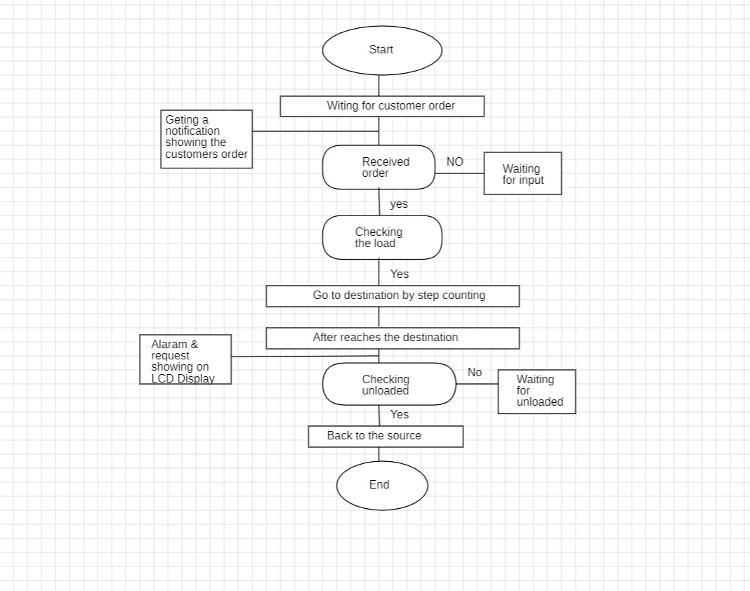

**Chapter 3**

**System Details**

3.1 Php

3.2 XAMPP

3.3 MySQL

3.4 HTML5

3.5 Bootstrap

3.6 Sublime Text

3.7 Git hub

3.8 Java script

3.9 CSS

**3.1 Php**

Hypertext Preprocessor (or simply PHP) is a a server-side scripting language used for general programming purposes as well as Web development. The PHP Group now produces the PHP reference implementation, which was first developed by Rasmus Lerdorf in 1994. Personal Home Page was the first meaning of PHP, however it has since evolved into PHP: Hypertext Preprocessor. PHP code can be used alone, in conjunction with different web template systems, web content management systems, and web frameworks, or it can be incorporated into HTML code. A PHP interpreter, which can be either a web server module or a Common Gateway Interface (CGI) executable, is typically used to process PHP code. The output of the interpreted and executed PHP code, which could be any kind of data, including graphics, is combined with the created web page by the web server. PHP code can be used to create standalone graphical apps and can also be run using a command-line interface (CLI).

**3.2XAMPP**

XAMPP is a stack of free and open source PHP and Perl interpreters, the MariaDB database, and the Apache HTTP Server are the primary components of Apache Friends' free and open source cross-platform web server solution stack. Cross-Platform (X), Apache (A), MariaDB (M), PHP (P), and Perl make up the acronym XAMPP (P). It is a straightforward, lightweight installation of Apache that makes setting up a local web server for testing and deployment very simple for developers. An extractable file contains the server program (Apache), database (MariaDB), and scripting language (PHP) required to set up a web server. Cross-platform means that XAMPP functions equally well on Linux, Mac, and Windows. Since XAMPP uses the same components.

**3.3 MySQL yog**

MySQL Workbench is a comprehensive visual tool for DBAs, database architects, and developers. Data modeling, SQL creation, and extensive administrative tools for server configuration, user management, backup, and other tasks are all provided by MySQL Workbench. There are versions of MySQL Workbench for Windows, Linux, and Mac OS X.

**3.4 HTML**

Hypertext Markup Language (HTML) is the industry-standard markup language for developing web apps and pages. It is one of three foundational technologies underpinning the World Wide Web, along with JavaScript and Cascading Style Sheets (CSS). HTML documents are downloaded from a web server or local storage by web browsers, who then turn them into multimedia web pages. HTML originally featured cues for the document's design and semantically explains the structure of a web page. The foundation of HTML pages are HTML components. Images and other objects, like interactive forms, may be embedded within the produced page using HTML techniques. By indicating structural semantics for text elements like headings, paragraphs, lists, links, quotations, and other objects, HTML offers a way to generate structured texts.

**3.5 Bootstrap**

Bootstrap is a front-end framework that is open-source and free to use while creating websites and web apps. It includes optional JavaScript extensions along with HTML and CSS-based design templates for navigation, buttons, forms, buttons, and other interface elements. It only addresses front-end development, unlike many web frameworks.

**3.6 Sublime Text**

Sublime Text is a commercial cross-platform source code editor that utilizes the Python programming language (API). Numerous programming and markup languages are supported natively, and users can add features through plugins, which are often developed and maintained by the local community under free-software licenses.

**3.7 GitHub**

GitHub is a Git-based version control hosting service on the internet. Code is where it is most frequently utilized. It has all of Git's distributed version control and source code management (SCM) features in addition to a few extras. Every project can benefit from access control and a variety of collaborative tools, including wikis, task management, issue tracking, and feature requests. Both private repositories and free accounts, which are frequently used to host open-source software projects, are available on GitHub.

**3.8 CSS**

Cascading Style Sheets (CSS) is a language for creating style sheets that describe how a document produced in a markup language like HTML will look. The World Wide Web's foundational technologies, along with HTML and JavaScript, include CSS. Layout, color, and font may all be separated from content and presentation using CSS. By describing the pertinent 11

CSS in a separate CSS file, this separation can make content more accessible, give definition of presentation features greater freedom and control, allow numerous web pages to share formatting, and reduce complexity and repetition in structural content.

**3.2 SOFTWARE USED:**

* HTML: Hyper Text Markup Language is the code used to structure a webpage and its content. HTML consists of a series of elements, which you can use to enclose, or wrap, different parts of the content to make it appear a certain way, or act a certain way. It determines the structure of web pages.
* CSS: Cascading Style Sheet is designed to enable the separation of presentation and content, including layout, colours, and fonts. The presentation of a document written in a markup language such as HTML. CSS helps Web developers create uniform look across several pages of a Web site. Instead of defining the style of each table and each block of text within a page's HTML, commonly used styles need to be defined only once in a CSS document.
* JavaScript: JavaScript is a scripting language primarily used on the web. It is used to enhance HTML pages and is commonly found embedded in HTML code. It is an interpreted language. It allows you to implement complex features on web pages — every time a web page does more than just sit there and display static information for you to look at — displaying timely content updates, interactive maps, animated 2D/3D graphics, scrolling video jukeboxes, etc.
* MYSQL: Structured Query Language which is a language used by databases. This language allows to handle the information using tables and shows a language to query these tables and other objects related as views, functions, and procedures.
* PHP: Hypertext preprocessor is a widely-used open source general-purpose scripting language that is especially suited for web development and can be embedded into HTML. When a website visitor accesses a PHP page, the web server processes, or "parses," the PHP code, which can output HTML to the webpage.

**Chapter 4**

**LIST OF FIGURES**

**4.1 Use case Diagram**

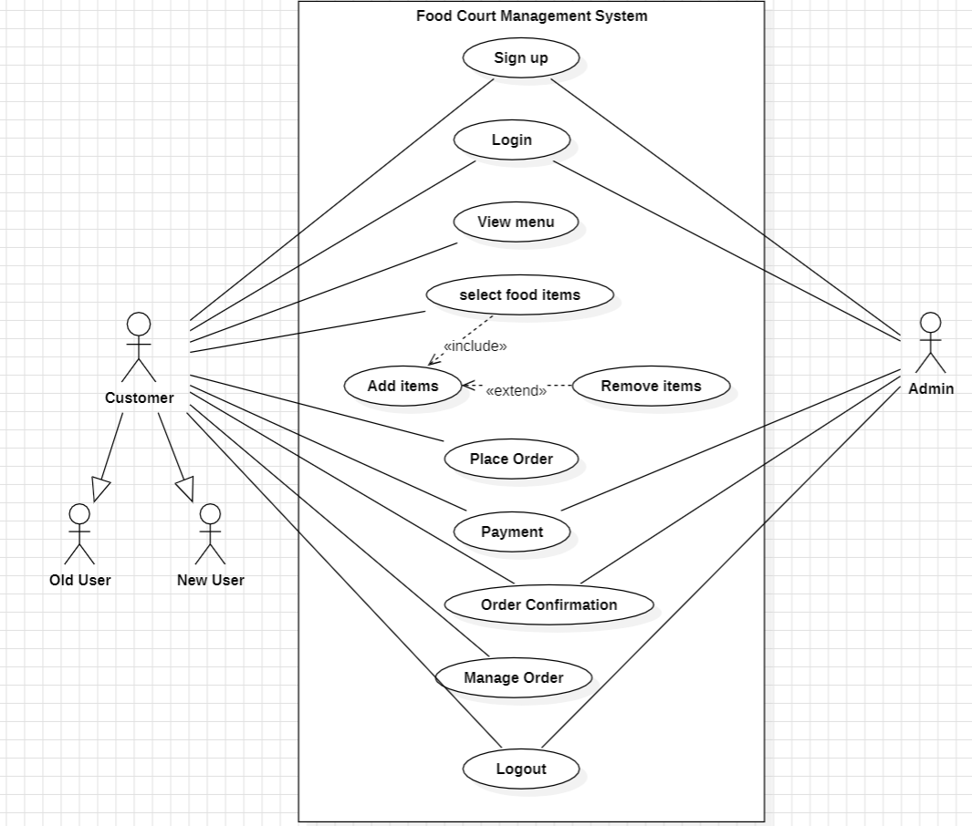

**4.2 ER Diagram**

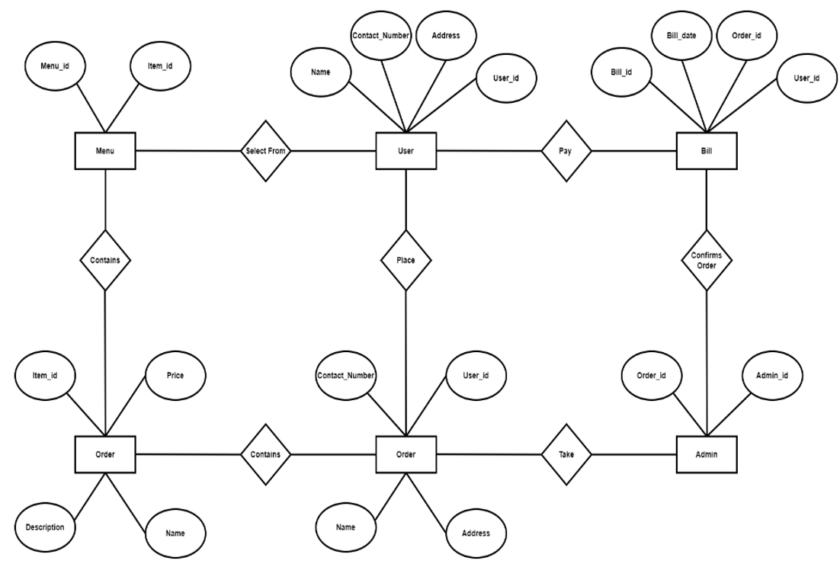

**4.3 Class Diagram**

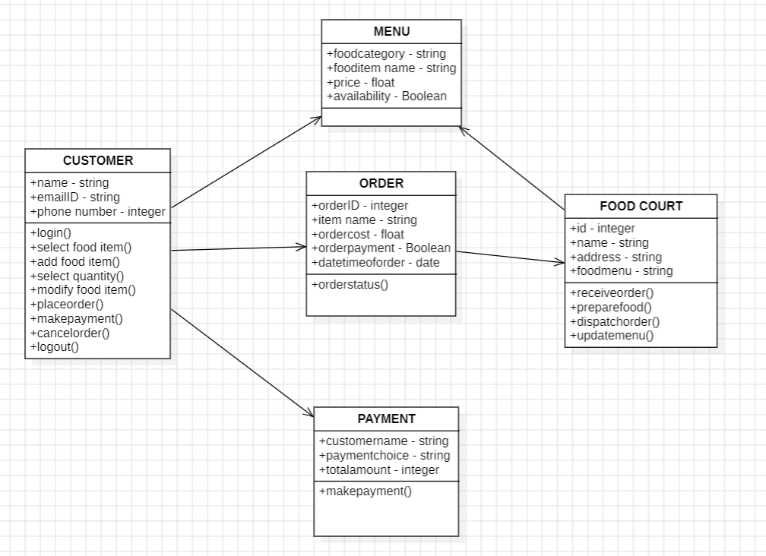

**4.4 Sequential Diagram**

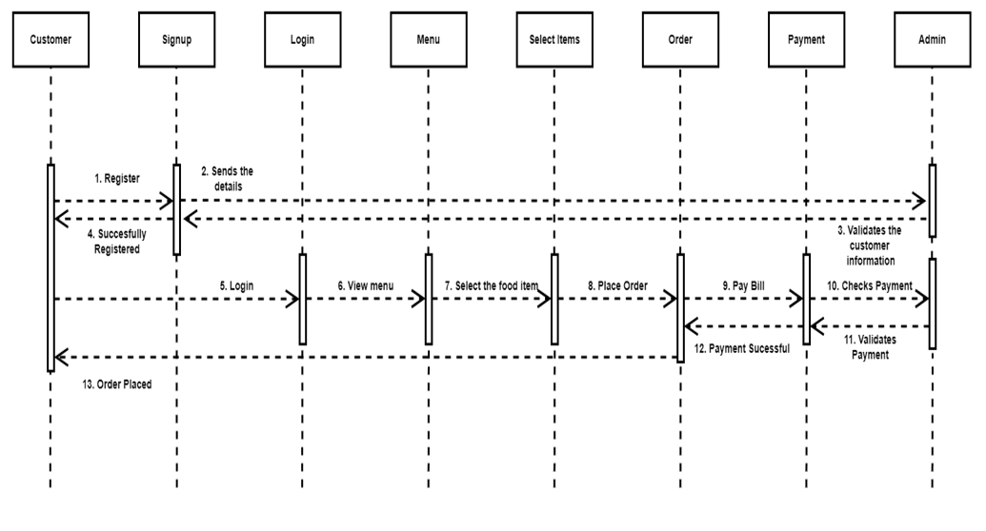

**4.5 Activity Diagram**

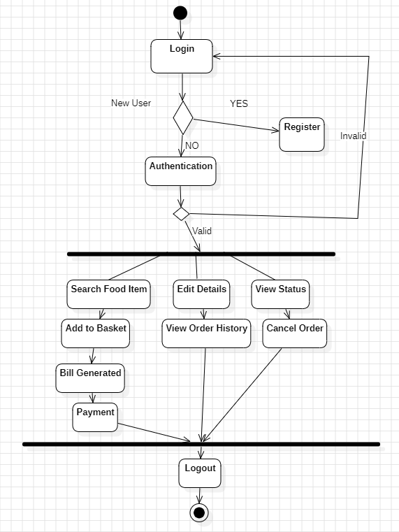

**Chapter 5**

**Cost Analysis**

**5.1 Development Costs**

**Human Resources:** The largest portion of development costs is attributed to the salaries or wages of developers, UI/UX designers, and other personnel involved in the project.

**Documentation:** Expenses related to the development of comprehensive documentation for users and developers.

**Promotional Materials:** Costs for creating promotional materials to introduce the canteen management system to customers.

**Onboarding Materials:** Costs associated with creating onboarding materials such as user manuals, Food materials, and guides.

**5.2 List of Components and their Cost:**

Visual Studio Code: Free to use.

My SQL: Free to use.

**Chapter 6**

**Results and Discussion**

FOR ADMIN:

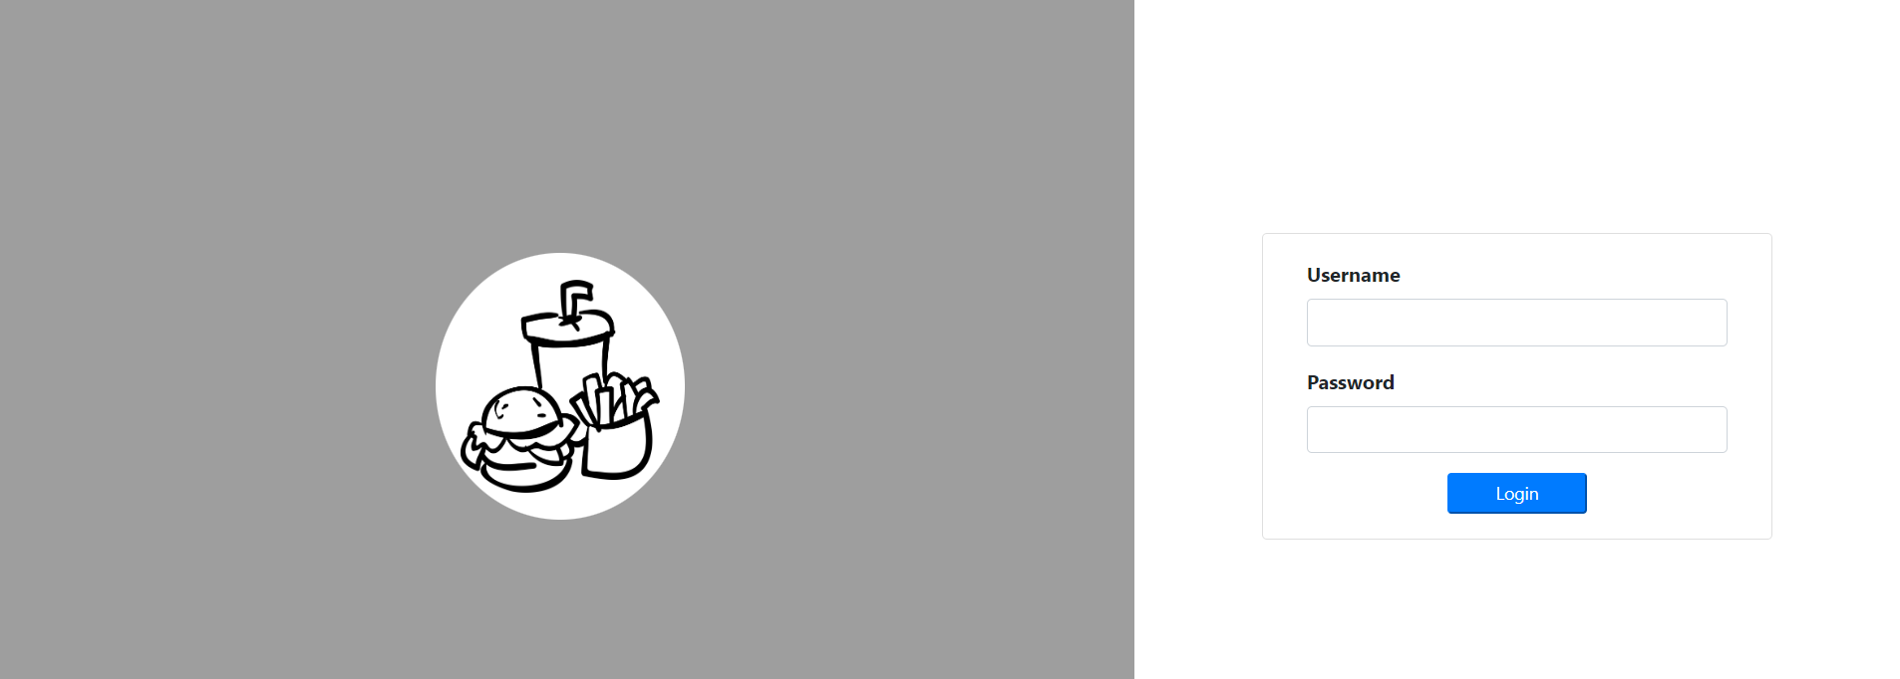

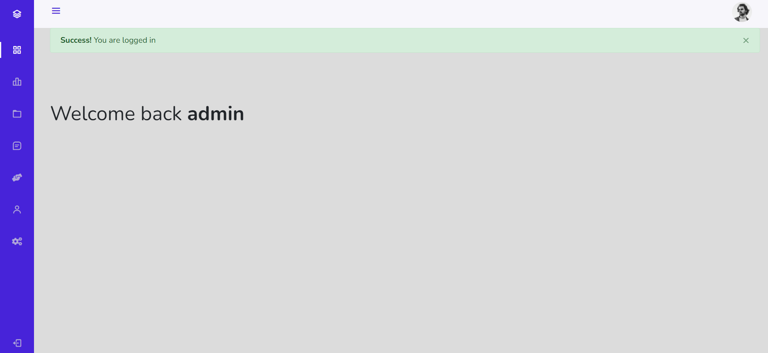

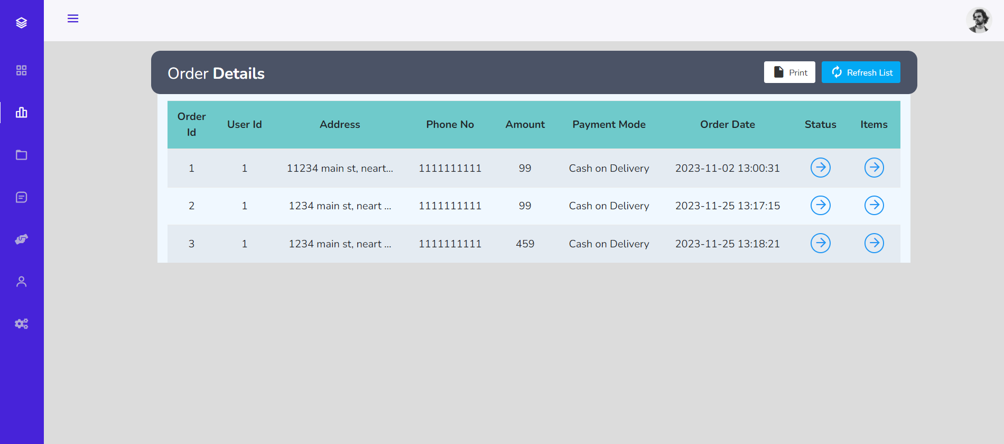

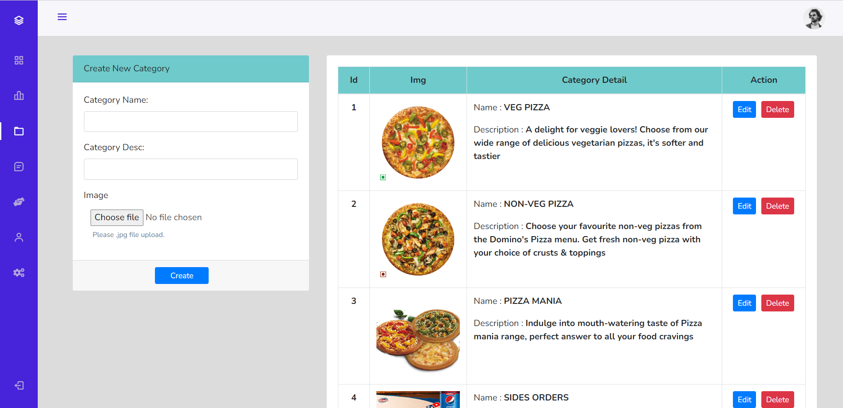

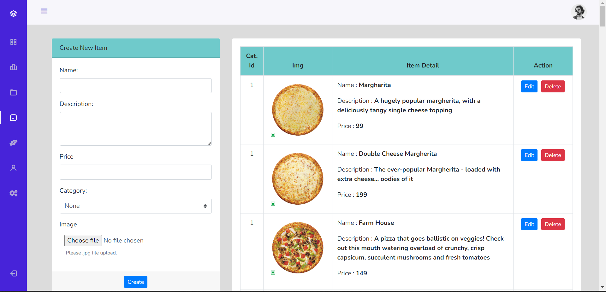

NEW USER REGISTRATION:

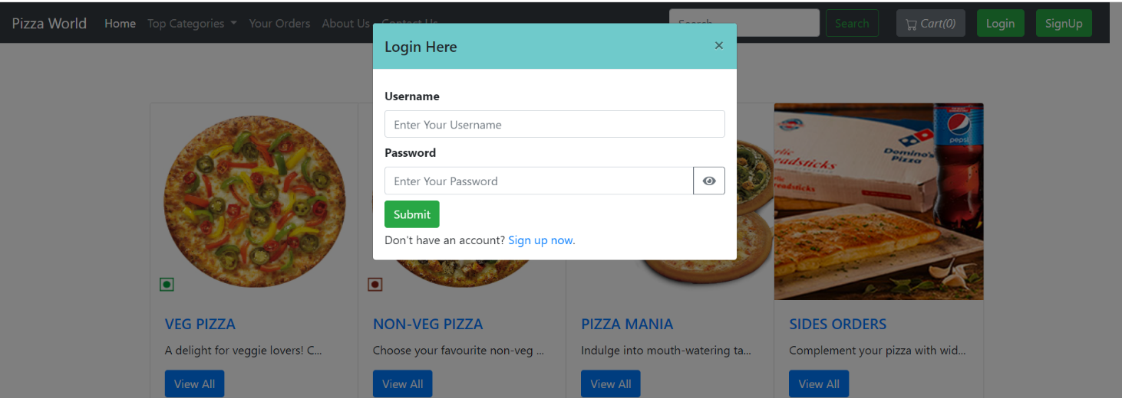

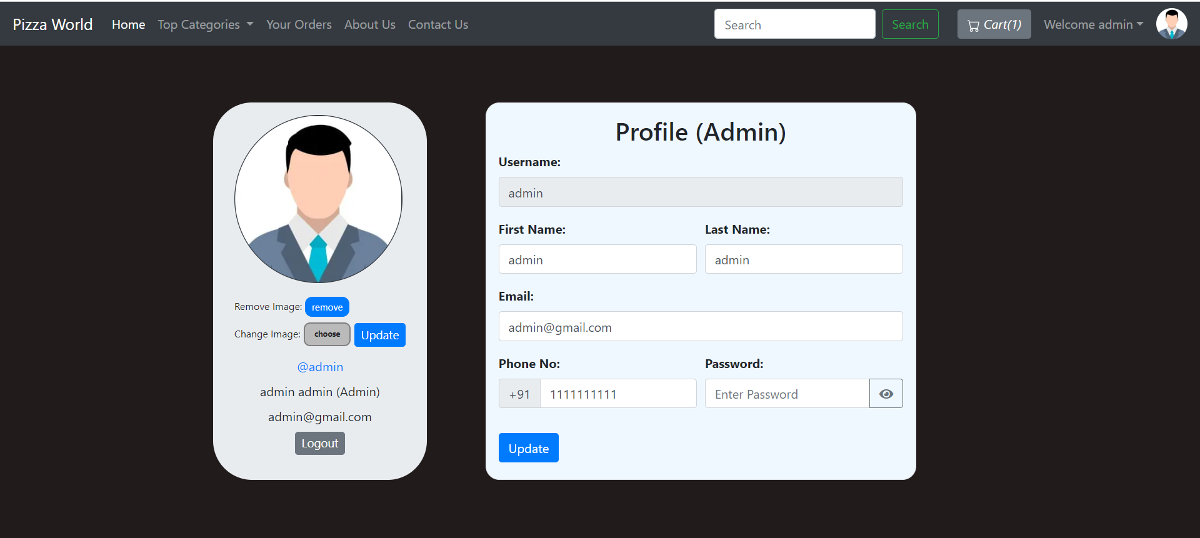

FOR USER:

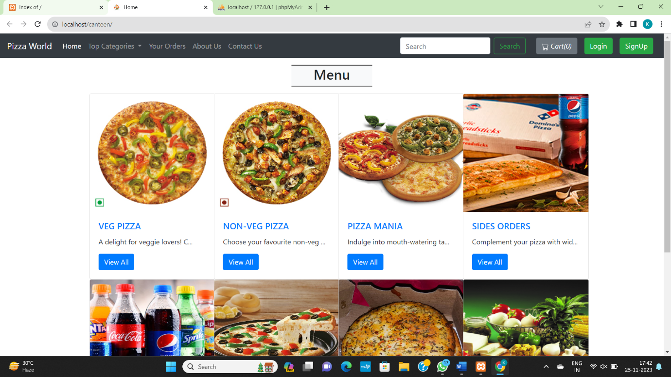

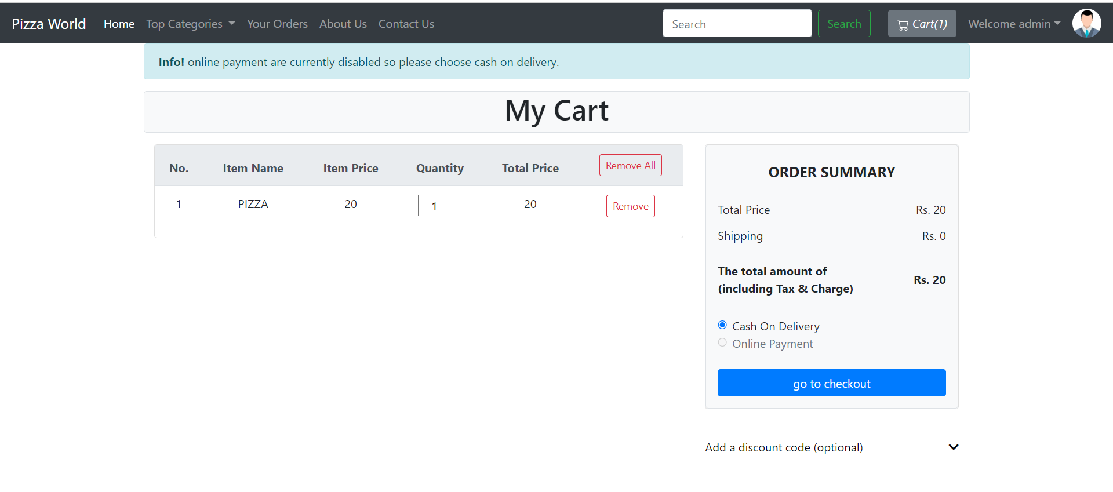

**Chapter 7**

**Conclusion & Future Work**

Restaurant Management System is a web-based technology that aids the restaurant industry in carrying out tasks effectively and efficiently. It aids in managing cash flow for managers. Managers can view analytics data to assess company growth. The manager can control orders and employee schedules by using this system. The full complement is a restaurant management system. It provides access to the Online Order platform, third-party connectors software, and comprehensive CRM solution, which together cover a sizable portion of your restaurant's requirements. They are not the outdated hardware and software sets for restaurants that were previously offered. They are the hottest things around, smooth, manageable, inexpensive, and quick.

In the "Food Court Based Web Application Project," we made every effort to meet all the demands of the restaurant. Because it is straightforward and adaptable, the project is successful. The biggest benefit of my project is that it draws plenty of users because of its simplicity. A novice user may operate it with ease. Any type of restaurant can utilize our software. By automating meal ordering, billing, and inventory control, the restaurant management system assists the restaurant manager in managing the restaurant more successfully and efficiently. The system handles the transaction and stores the data produced. These data will be used to create reports that assist the restaurant manager in making wise business decisions. For example, the manager can decide whether more waiters, delivery men, delivery carts, and cooks are needed based on how many clients will be present during a specific time period. When this project is finished, all security concerns will be resolved. Additionally, a quick and secure authentication process will be used for record maintenance. Because it automatically pulls information about a consumer from the database on subsequent visits, data entry is quick and easy. As a result, our program will undoubtedly succeed in replacing the antiquated manual way of storing secure information. The work plan also specifies the specific front end and back end characteristics of the technology being used in the project. Future project goals and its scope have been elaborated.

**Future Work:**

The present system depends on online management. This can be improvised by the automation of the software. The data storing will take time and requires manual observation. With the help of automation, it would store the data instantly. This will reduce the effort and time the manual observation. The updated data will be finalized and alerted from time to time to the admin. The machine learning algorithms can also be used for the prediction of the most preferred item by the customers. The customers will give feedback and this will be sent to the database.

Each project should pay close attention to future development because it contains the system's most recent features. It lessens software issues and defects. It develops a close relationship with customers based on their comments or preferences. Developer will incorporate certain dynamic elements that are briefly described below into my restaurant management system.

Reporting module with real time mechanism.

• Modern architecture with smooth transitions.

• System for email and mobile confirmation.

• Selling Point

**Appendices :**

**Video Explanation Link :** [**https://vitapacin.sharepoint.com/sites/SPMREVIEW5/Shared%20Documents/General/Recordings/New%20channel%20meeting-20240424_214644-Meeting%20Recording.mp4?web=1&referrer=Teams.TEAMS-ELECTRON&referrerScenario=MeetingChicletGetLink.view.view**](https://vitapacin.sharepoint.com/sites/SPMREVIEW5/Shared%20Documents/General/Recordings/New%20channel%20meeting-20240424_214644-Meeting%20Recording.mp4?web=1&referrer=Teams.TEAMS-ELECTRON&referrerScenario=MeetingChicletGetLink.view.view)

**Customer work flow :**

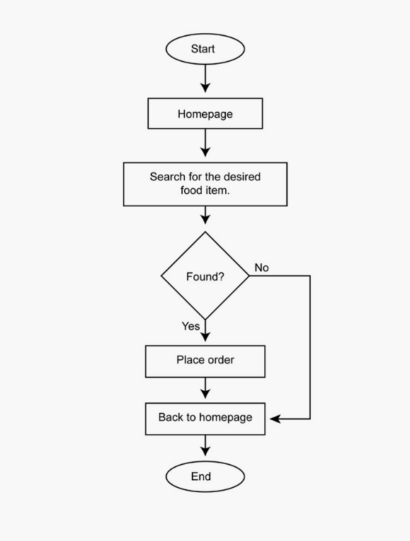

**System design model:**

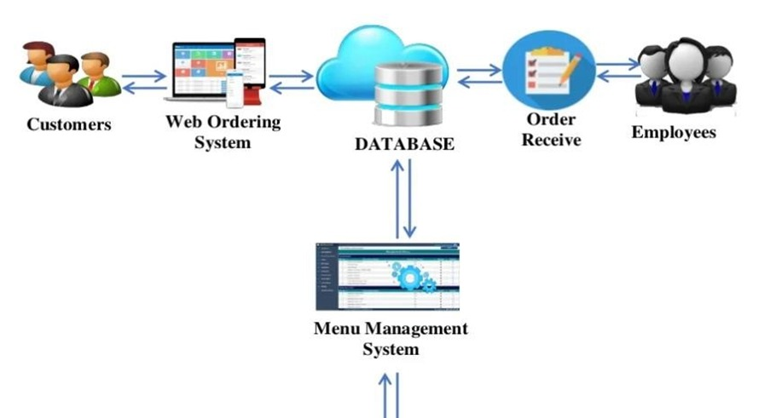

**REFERENCES**

**[1]** Kirti Bhandge, Tejas Shinde, Dheeraj Ingale, Neeraj Solanki, Reshma Totare,”A Proposed System for Touchpad Based Food Ordering System Using Android Application”, International Journal of Advanced Research in Computer Science Technology (IJARCST 2015).

**[2]** Varsha Chavan, Priya Jadhav,Snehal Korade,Priyanka Teli, ”Implementing Customizable Online Food Ordering System Using Web Based Application”, International Journal of Innovative Science, Engineering Technology(IJISET) 2015.

**[3]** Resham Shinde, Priyanka Thakare, Neha Dhomne, Sushmita Sarkar, ”Design and Implementation of Digital dining in Restaurants using Android”, International Journal of Advance Research in Computer Science and Management Studies 2014.

**[4]** Ashutosh Bhargave, Niranjan Jadhav, Apurva Joshi, Prachi Oke, S. R Lahane,“Digital Ordering System for Restaurant Using Android”, International Journal of Scientific and Research Publications 2013.

**[5]** Khairunnisa K., Ayob J., Mohd. Helmy A. Wahab, M. Erdi Ayob, M. Izwan Ayob, M. Afif Ayob, ”The Application of Wireless Food Ordering System” MASAUM Journal of Computing 2009.

**[6]** Noor Azah Samsudin, Shamsul Kamal Ahmad Khalid, Mohd Fikry Akmal Mohd Kohar, Zulkifli Senin, Mohd Nor Ihkasan,” A customizable wireless food ordering system with real time customer feedback”, IEEE Symposium on Wireless Technology and Applications(ISWTA) 2011. **[7]** Serhat Murat Alagoza, Haluk Hekimoglub,” A study on tam: analysis of customer attitudes in online food ordering system”, Elsevier Ltd. 2012.

**[8]** Patel Krishna, Patel Palak, Raj Nirali, Patel Lalit,” Automated Food Ordering System”, International Journal of Engineering Research and Development (IJERD) 2015.

**[9]** Mayur D. Jakhete, Piyush C. Mankar,” Implementation of Smart Restaurant with e-menu Card,” International Journal of Computer Applications 2015 of Smart Restaurant with e-menu Card,” International Journal of Computer Applications.

**[10]** Abhishek Singh, Adithya R, Vaishnav Kanade, Prof. Salma Pathan“ ONLINE FOOD ORDERING SYSTEM” International Research Journal of Engineering and Technology (IRJET) 2018.